

**Data Technician**

|  |
| --- |
|  |

|  |
| --- |
| Name: Shaun Bak |
| Course Date: 15/12/2025- 18/12/2025 |
|  |

**Table of contents**

Day 1: Task 1 3

Day 1: Task 2 3

Day 1: Task 3 4

Day 2: Task 1 5

Day 3: Task 1 9

Day 3: Task 2 10

Day 3: Task 3 11

Day 4: Task 1 12

Day 4: Task 2 13

1. Scenario Background 13

2. Data Laws and Regulations 14

3. Azure Service Recommendations 14

4. Data Types and Data Modelling 14

5. Data Storage Formats and Structures in Azure 14

6. Additional Considerations 15

Submission Guidelines: 15

Course Notes 17

Additional Information 17

# Day 1: Task 1

Please research and complete the below questions relating to key concepts of cloud.

Be prepared to discuss the below in the group following this task.

|  |  |
| --- | --- |
| What can cloud computing do for us in the real-world? | Cloud computing offers significant benefits such as cost efficiency and scalability, allowing businesses to adjust resources based on demand. It enhances accessibility, enabling remote work and seamless collaboration among teams. With robust data backup and recovery options, organizations can securely store their information. Additionally, cloud services foster innovation by allowing companies to deploy applications quickly. Overall, cloud computing transforms operations and improves efficiency, driving better business outcomes. |
| How can it benefit a business? | It can benefit a business by being cost-efficient.  Cloud computing helps businesses save money and work more efficiently. Instead of buying and maintaining expensive servers, companies can rent computing power and storage from providers and only pay for what they use. This makes it easy to adjust resources when demand changes and provides access to modern tools such as data analytics and automation, which accelerate innovation and reduce the time to launch new products or services.  It also strengthens teamwork and security. Employees can access files and apps from anywhere, which supports remote work and global collaboration. Cloud providers handle updates, backups, and cybersecurity, so businesses can focus on growth while knowing their data is protected. Overall, cloud computing keeps companies flexible, competitive, and ready for the future. |
| What’s the alternative to cloud computing? | An alternative to cloud computing is relying on on-premises infrastructure or self-hosting, where businesses keep their servers, storage, and networking equipment in-house, giving them complete control over systems and data but requiring higher upfront investment and ongoing maintenance. Other models include fog computing and edge computing, which process data closer to the source—such as IoT devices or sensors—reducing latency and improving speed for real-time applications like manufacturing, healthcare, or autonomous vehicles. Hybrid and multi-cloud approaches also serve as alternatives, combining private infrastructure with public cloud services to balance control, scalability, and cost. Each option comes with trade-offs: on-premises offers privacy and customisation but lacks easy scalability, while fog and edge computing excel at speed but may not provide the global reach of cloud platforms. Ultimately, businesses choose alternatives based on their priorities, whether that’s tighter data control, faster local processing, or avoiding dependence on a single cloud provider. |
| What cloud providers can we use, what are their features and functions? | |  |  |  |  | | --- | --- | --- | --- | | Features | AWS | Azure | GCP | | Virtual Server | Instances  ( Virtual Machine ) | VM’s  (Virtual Machine ) | VM instances  (customizable computing power—CPU, memory, storage, and networking—that you can tailor to your workload,) | | File Storage | EFS(fully managed, scalable file storage service) | Azure files  (cloud file‑sharing service that provides accessible, scalable file shares over standard protocols like SMB and NFS) | Zfs/ Avere  (advanced file system  and volume manager  **designed to provide high reliability, scalability, and integrated storage management.**  ) | | Global Content Delivery | Cloud Front ( Functions as a Content Delivery Network (CDN) that speeds up the delivery of websites, videos, APIs, and other content by caching copies at servers located around the world.) | Delivery Network (CDN works by caching content at strategically placed servers (edge nodes) around the globe, so users receive data from the closest location, reducing latency and improving performance) | Cloud CDN  **(**Google Cloud Platform (GCP) offers a global cloud infrastructure and services similar to AWS and Azure, but with deep integration into Google’s ecosystem. ) | |

# Day 1: Task 2

Please research the cloud offerings below, explain what they are, and provide examples of use cases.

|  |  |  |
| --- | --- | --- |
| Cloud Offerings | Explain what it is | When / how might you use this service in the real world? |
| IaaS (Infrastructure as a service) | IaaS, or Infrastructure as a Service, is a cloud computing model that lets businesses rent virtual computing resources like servers, storage, and networking over the internet instead of owning physical hardware. This model helps organizations scale their resources as needed, pay only for what they use, and avoid the costs and complexities of managing their own infrastructure. | IaaS allows organizations to rent computing infrastructure instead of buying hardware. This is useful for:  Hosting Website: Businesses can manage websites without needing their own servers and can easily adjust resources based on traffic.  Running Applications: Companies can run applications in the cloud, providing flexibility and reducing the need for physical equipment.  Analyzing Large Datasets: IaaS enables efficient processing of large data sets, making big data analysis more affordable.  Scaling Services Quickly: Organisations can easily adjust their services based on current needs without waiting for new hardware.  Using IaaS helps companies focus on their primary goals, leading to greater flexibility and innovation. |
| PaaS (Platform as a Service) | Platform as a Service (PaaS) is a cloud computing model that provides developers with an environment to create and manage applications without managing the underlying hardware or infrastructure. PaaS providers, such as Microsoft Azure and AWS, handle tasks like server setup and maintenance, so developers can focus on writing code and developing features. This makes app development faster, cheaper, and easier by removing the technical complexities. | Startups can use platforms like Heroku to develop web applications efficiently, minimizing infrastructure concerns. Azure API Management allows for easy API development, leveraging built-in security and scalability. Mobile Backend: Solutions like Firebase enable developers to manage mobile app back-ends while focusing on user experience. Collaboration: GitHub Code spaces foster effective teamwork among remote developers on shared codebases. Data Analytics: Tools such as Google Cloud Big Query simplify the analysis of large datasets for better decision-making. By streamlining infrastructure management, PaaS allows teams to concentrate on developing and delivering applications. |
| SaaS (Software as a service) | An SaaS (Software as a Service) is a cloud-based software delivery model where applications are hosted by a provider and accessed by users via the internet, typically through a web browser. Instead of installing and maintaining software locally, customers subscribe to it, and the provider manages updates, security, and infrastructure. | You’d use SaaS whenever you need software that’s accessible everywhere, easy to scale, and doesn’t require extensive IT management. A housing project wants to track information about tenants, such as compliance and financial data. The most effective way to do this would be to create a data sheet, upload it into Power BI, then prepare a dashboard and publish. |

# Day 1: Task 3

Please research the below terms and explain what they are, when they would be appropriate and a real-world example of where it could be implemented (i.e. what type of organisation).

|  |  |
| --- | --- |
| Public Cloud | A public cloud is a cloud computing model in which a third-party provider delivers IT resources such as servers, storage, and applications via the internet. These resources are shared among many users, meaning you don’t own the infrastructure. Instead, you subscribe to or rent the services, paying only for what you consume. This setup offers scalability, flexibility, and cost-effectiveness, making it an attractive option for businesses of all sizes. Public cloud is ideal when you need rapid scalability, lower costs, fast deployment, global access, and advanced services such as AI or big data analytics, without building infrastructure yourself. Netflix runs its streaming service on Amazon Web Services (AWS), which enables easy resource scaling during peak periods, such as new show releases. This approach eliminates the need for costly server farms. Additionally, AWS ensures low-latency content delivery worldwide and provides advanced analytics and machine learning tools for personalised show recommendations. |
| Private Cloud | A private cloud is a cloud computing environment dedicated to a single organisation, offering enhanced security, control, and compliance compared to public clouds. It’s most appropriate for industries that handle sensitive data or require strict regulatory compliance. A real-world example is a hospital using a private cloud to securely store patient records and comply with HIPAA regulations. |
| Hybrid Cloud | A hybrid cloud is a computing environment that combines public cloud services with private cloud or on-premises infrastructure, allowing organisations to balance scalability, cost efficiency, and security. It’s most appropriate when businesses need to keep sensitive data secure while still leveraging the flexibility and scalability of public clouds. A real-world example is a bank using a hybrid cloud to process secure transactions in a private cloud while running customer-facing apps on a public cloud. |
| Community Cloud | *A community cloud is a shared cloud infrastructure created for multiple organisations with common goals, regulatory requirements, or industry-specific needs. It’s suitable when organisations need secure collaboration but cannot depend on public clouds due to compliance or cost issues. An example from the healthcare sector is where hospitals and clinics share a community cloud to securely exchange patient data while adhering to strict privacy regulations.* |

# Day 2: Task 1

Describe, with examples, the **three** major areas that the Computer Misuse Act deals with.

|  |  |  |
| --- | --- | --- |
| Area | Description | Example |
| unauthorised access to computer material  section 1 | Accessing a computer system without permission is often referred to as basic hacking | Using someone else’s password to log into their email or social media without consent. |
| Unauthorised Access to commit or Assist in Further Crimes (Section 2) | Illegally gaining access to a computer with the intent to commit additional crimes like fraud or theft. | Accessing a company’s database to steal customer credit card information for identity theft. |
| Unauthorised Modification of Computer Material (Section 3)  . | Intentionally modifying, deleting, or damaging computer data or software without authorisation. | Distributing malware or viruses that damage files. |

The computer misuse act 1990 is an act where an individual can be criminalised because of computer related offense. Describe three extra powers that the Police and Justice Act 2006 (Computer Misuse) has added.

|  |
| --- |
| Description |
| 1. Increase penalties for hacking from 5 to 10 years in prison.  2. Making denial of service (DoS) attacks explicitly illegal.  3. Criminalising the production, distribution, or possession of “hacker tools” designed for malicious use. |
|  |
|  |

Look at the below website to answer the questions:

<https://www.gov.uk/personal-data-my-employer-can-keep-about-me>

|  |
| --- |
| Write down three items of data which a company can store about an employee. |
| Name |
| Address |
| Date of Birth |

|  |
| --- |
| Give three more examples of data that an employer can only store if they first get the employee’s permission. |
| Race or Ethnicity  Political opinions or membership  Religion |
|  |
|  |

Conduct further research to answer the below questions.

|  |  |
| --- | --- |
| Question | Answer |
| Provide one example of: Copyright infringement | Imagine someone posts the entire text of a popular novel, such as Harry Potter and the Philosopher’s Stone, on their personal blog without permission from the copyright holder, like J.K. Rowling and her publishers. |
| Provide one example of: Plagiarism | Imagine a student working on an essay about climate change who comes across this sentence in a published article: “Climate change is accelerating the frequency and intensity of extreme weather events worldwide.”  Then, they copy this statement and add it to his or her essay. This act is the actual plagiarism |
| What are two effects of copyright infringement and software piracy? | Economic Impact on Creators: Copyright infringement and software piracy can cause substantial financial losses for creators and companies. When their work is illegally copied or distributed, they forgo potential sales and revenue, which can hinder their ability to invest in future projects or sustain their business. 2. Reduced Quality of Products: The widespread presence of pirated software can flood the market with low-quality or insecure products. Users may choose illegal copies over legitimate versions, leading to a lack of funding for updates, customer support, and ongoing development, ultimately reducing the overall quality of available software. |
| Give three possible consequences for individuals when using pirated software | Software can eventually become corrupted, which means you might not be able to use it reliably or at all. This corruption can also cause hard drive failure, making it unusable. In some cases, it can damage the entire machine, requiring you to replace the hard drive or even throw away the computer altogether. There are no updates or only a limited number of official updates that will work with the pirated software, again making reliability uncertain. |

Listed below are some laws which we have covered today:

1. Computer Misuse Act 1990

2. Police and Justice Act 2006 (Computer Misuse)

3. Copyright, Designs and Patents Act 1988

4. Copyright (Computer Programs) Regulations 1992

5. The Health and Safety (Display Screen Equipment) Regulations 1992

6. Data Protection Act 2018

7. Consumer Rights Act 2015

* Insert a number in the first column of each row to match each of the statements with one of the above Acts.
* One of statements is incorrect and not illegal. For this statement, write ‘Not illegal’.

|  |  |
| --- | --- |
| **Act number** | **Clause** |
| 4 Copyright 1992 | With some exceptions, it is illegal to use unlicensed software |
| 5 Health and Safety 1992 | Any product, digital or otherwise, must be fit for the purpose it is supplied for |
| 1 Computer misuse 1990 | Unauthorised modification of computer material is illegal |
| 1 Computer misuse 1990 | It is illegal to create or use a hacking tool for penetration testing |
| 6 Data protection act 2018 | Personal data may only be used for specified, explicit purposes |
| 5H&S 1992 | Employers must provide their computer users with adequate health and safety training for any workstation they work at |
| 1 Computer misuse 1990 | It is illegal to distribute hacking tools for criminal purposes |
| 3 Copyright Act 1988 | It is illegal to distribute an illicit recording |
| 6 Data protect acrt 2018 | Personal data may not be kept longer than necessary |
| 1 Computer misuse 1990 | Gaining unauthorised access to a computer system is illegal |
| 5 H&S 1992 | Employers must ensure that employees take regular and adequate breaks from looking at their screens. |
| 1 Computer misuse 1990 | It is illegal to prevent or hinder access (e.g. by a denial-of-service attack) to any program or data held in any computer |
| False | Personal data must be accurate and where necessary kept up to date |

# Day 3: Task 1

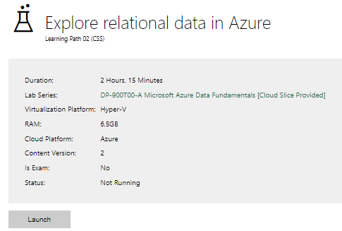

|  |  |
| --- | --- |
| Completed lab |  |

# Day 3: Task 2

Please complete the below lab (4) *‘Explore non-relational data in Azure’* and paste evidence of the completed lab in the box provided.

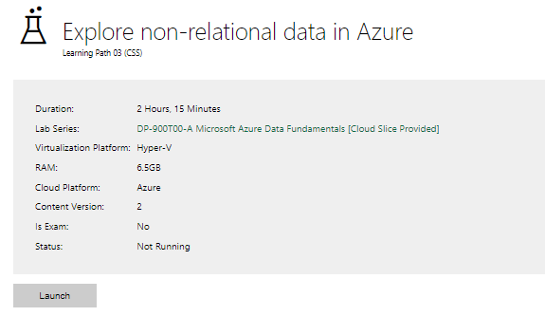

|  |  |
| --- | --- |
| Completed lab |  |

# Day 3: Task 3

Please complete the below lab (5) ‘Explore data analytics in Azure’ and paste evidence of the completed lab in the box provided.

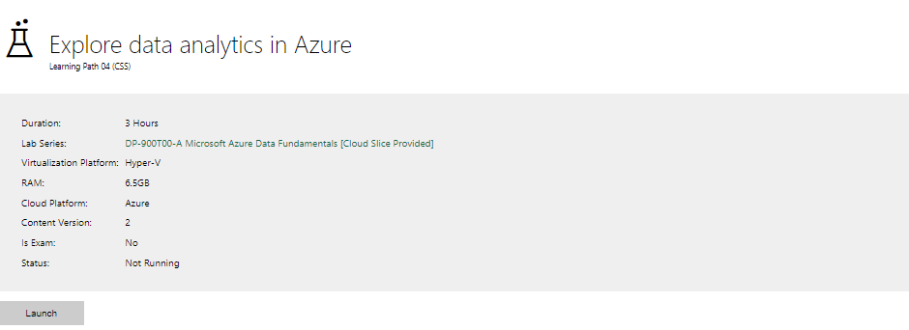

|  |  |
| --- | --- |
| Completed lab |  |

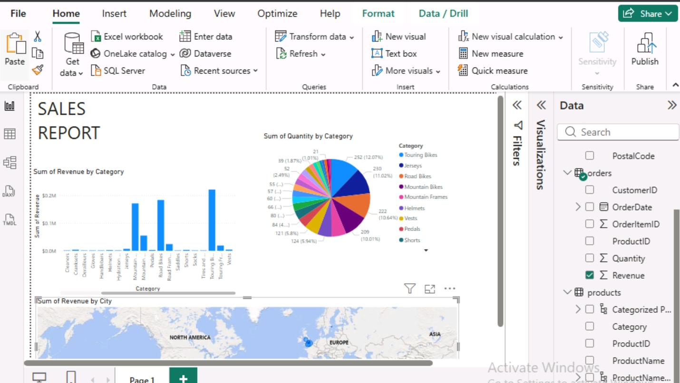

# Day 4: Task 1

In your teams, complete the Azure DP-900 practice exam and paste your result below – this is open book and please research and discuss your answers as a team.

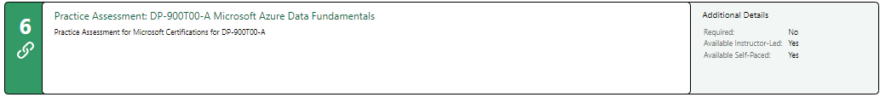

|  |  |
| --- | --- |
| Result |  |

# Day 4: Task 2

#### **1. Scenario Background**

"Paws & Whiskers" is a growing pet shop that aims to improve its business by analysing sales, customer information, and inventory data. Currently, the data is collected manually or stored in spreadsheets. Management is interested in transitioning to Microsoft Azure to streamline data storage, analysis, and reporting, enabling them to make data-driven decisions.

#### **2. Data Laws and Regulations**

Identify and explain the data laws and regulations relevant to handling customer data within the proposal. Ensure you cover the following points:

* **GDPR Compliance**: Highlight the importance of adhering to the General Data Protection Regulation (GDPR), particularly as it relates to storing and processing customer information.
* **Data Protection Act (DPA) 2018**: Outline how the DPA 2018 may affect the way "Paws & Whiskers" collects and stores data, ensuring compliance with UK laws on data privacy.
* **Other Industry Standards**: Research any additional data protection standards or regulations that may apply to pet shop data, particularly if they involve sensitive or payment information.

#### **3. Azure Service Recommendations**

Recommend Microsoft Azure services that would suit the company’s data analysis needs and explain why these services are suitable. Your recommendations should include:

* **Data Storage**: Identify suitable storage options, such as **Azure Blob Storage** or **Azure SQL Database**, and discuss the benefits of each for storing large datasets, including inventory, sales transactions, and customer details.
* **Data Analysis Tools**: Recommend tools such as **Azure Machine Learning** for customer behaviour analysis or **Azure Synapse Analytics** for analysing sales trends.
* **Data Integration and Automation**: Explain how services like **Azure Data Factory** could automate data collection and integration processes, improving efficiency.

#### **4. Data Types and Data Modelling**

Define the types of data "Paws & Whiskers" will need to work with and describe your approach to data modelling:

* **Data Categories**: Identify key data types, such as customer demographics, transaction history, pet inventory, and product categories.
* **Data Modelling Approach**: Outline how you would structure this data using a relational model or a data warehouse approach, considering factors like tables, entities, relationships, and primary keys.

#### **5. Data Storage Formats and Structures in Azure**

Discuss how you would store data within Azure and the formats you would recommend:

* **Data Formats**: Specify recommended formats (e.g., CSV for raw data imports, JSON for structured data, Parquet for analytics) and explain why these formats are suitable for specific data types.
* **Data Security and Encryption**: Include recommendations for securing data using Azure’s built-in encryption features and access controls to ensure compliance with data privacy regulations.

#### **6. Additional Considerations**

Provide any other considerations that might enhance data handling and efficiency in Azure, such as:

* **Backup and Disaster Recovery**: Outline a backup plan using **Azure Backup** or **Azure Site Recovery** to safeguard against data loss.
* **Data Visualisation**: Discuss potential use of **Power BI** within Azure for creating dashboards that provide management with real-time insights into sales and customer trends.
* **Future Scalability**: Comment on how Azure services can scale as the business grows, accommodating larger datasets and more complex analyses.

### **Submission Guidelines:**

1. **Structure**: Ensure your report is well-organised, with sections for each task (e.g., Data Laws, Azure Services, Data Types, etc.).
2. **Formatting**: Include headings, bullet points where appropriate, and any visuals or diagrams that support your explanations.
3. **References**: Cite any resources or regulations referenced in the report.
4. **Length**: Aim for 1500-2000 words.

|  |
| --- |
|  |

|  |
| --- |
| **Course Notes** |

It is recommended to take notes from the course, use the space below to do so, or use the revision guide shared with the class:

|  |
| --- |
| **Additional Information** |

We have included a range of additional links to further resources and information that you may find useful, these can be found within your revision guide.

**END OF WORKBOOK**

**Please check through your work thoroughly before submitting and update the table of contents if required.**

**Please send your completed work booklet to your trainer.**